|  |  |
| --- | --- |
| |  | | --- | | **Kaiburr -** Coding Assessment | |

Task 1. Java REST API example.

Implement an application in java which provides a REST API with endpoints for searching.

creating and deleting "server" objects:

⚫ GET servers. Should return all the servers if no parameters are passed. When server id is passed as a parameter - return a single server or 404 if there's no such a server.

****@GetMapping Annotation****

A)This annotation specifies the URL that this method maps to and also specifies that it is an HTTP GET Request. It is a composite annotation that acts as a shortcut for @RequestMapping(method = RequestMethod.GET). This is specified for the getAllPersons and getPersonWithId methods.

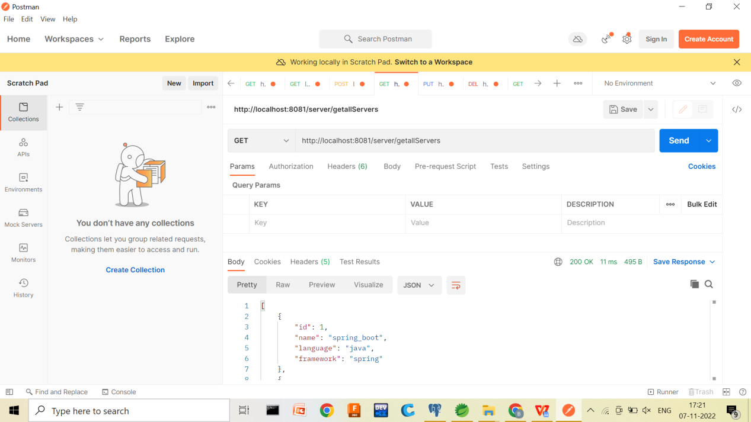

⚫ PUT a server. The server object is passed as a json-encoded message body. Here's an

example:

"name": "my centos", "id":"123",

"language":"java", "framework":"django"

A)@PutMapping: This spring boot annotation is **used for handling the incoming put request from the client side**.

As we know PUT HTTP method is used to update/modify the resource so the *@PutMapping* annotation is used for mapping HTTP PUT requests onto specific handler methods.

Specifically, **@PutMapping** is a composed annotation that acts as a shortcut for @RequestMapping(method = RequestMethod.PUT).

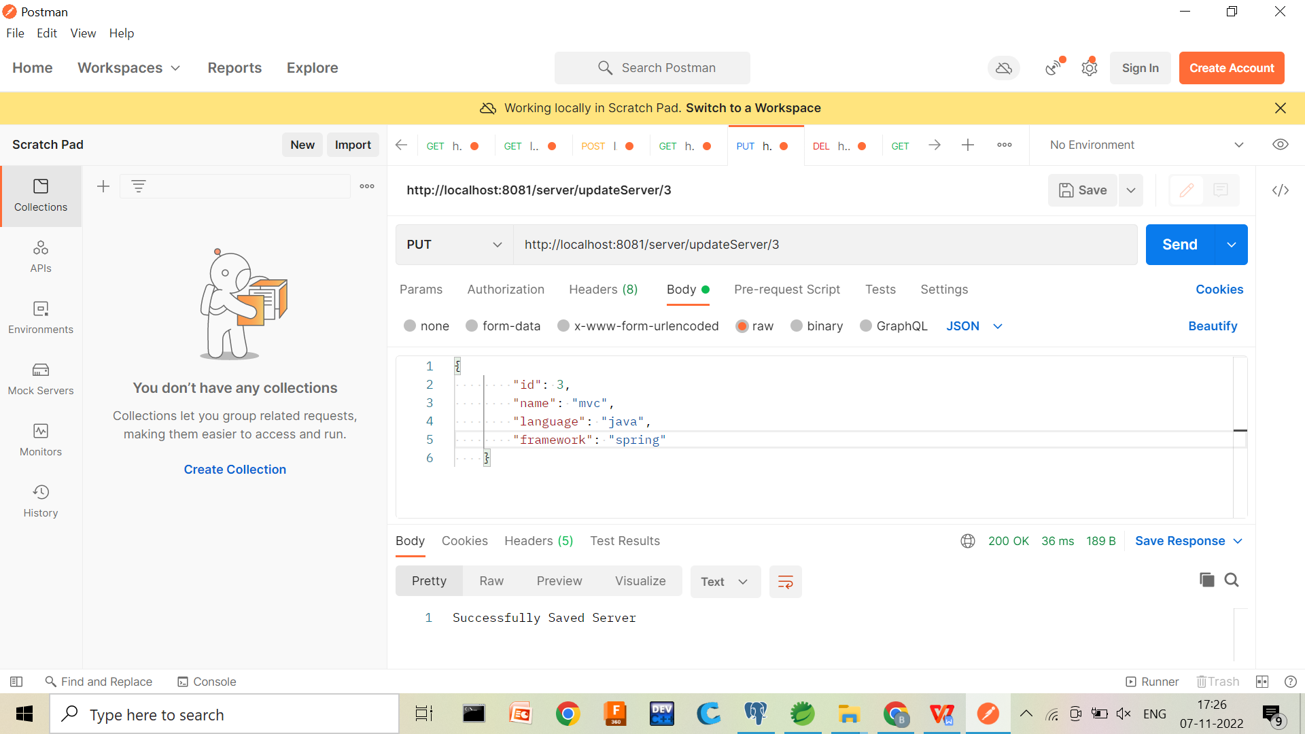

⚫DELETE a server. The parameter is a server ID.

What is delete mapping in Spring boot?

A)@DeleteMapping annotation **maps HTTP DELETE requests onto specific handler methods**. It is a composed annotation that acts as a shortcut for @RequestMapping(method = RequestMethod. DELETE) .

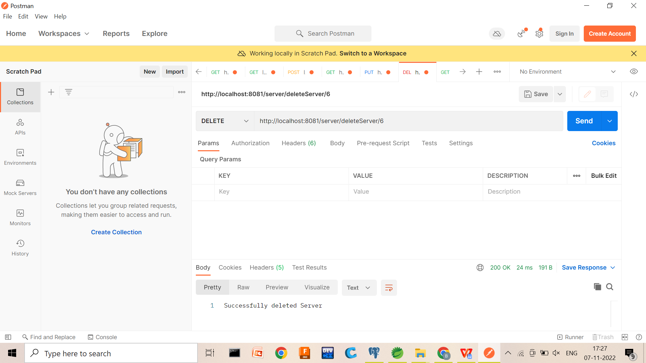

⚫ GET (find) servers by name. The parameter is a string. Must check if a server name contains this string and return one or more servers found. Return 404 if nothing is found.

A)JPA finder methods are the most powerful methods, we can **create finder methods to select the records from the database without writing queries**. Behind the scenes, Data JPA will create queries based on the finder method and execute the query for us.

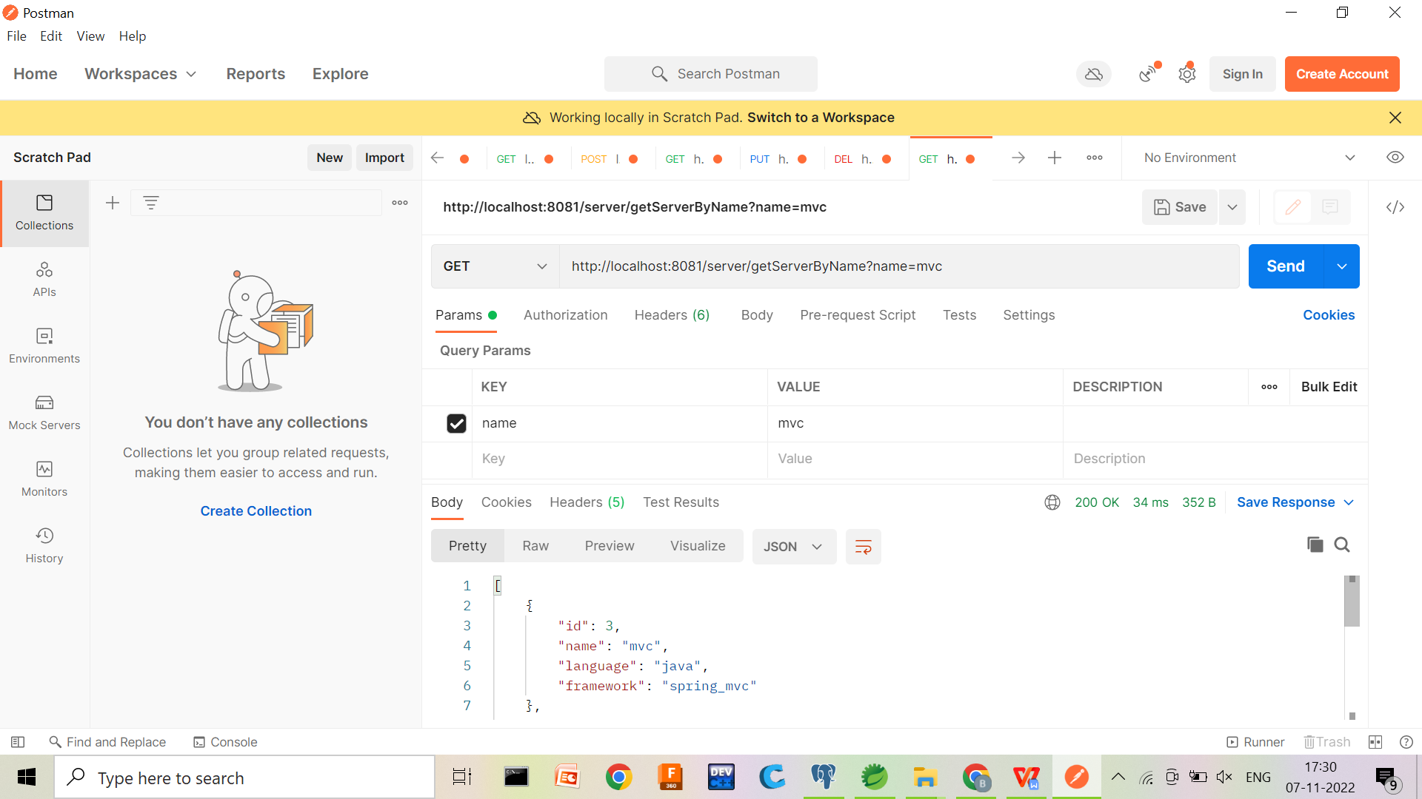

"Server" objects should be stored in MongoDB database

Be sure that you can show how your application responds to requests using postman, curl or any other HTTP client.